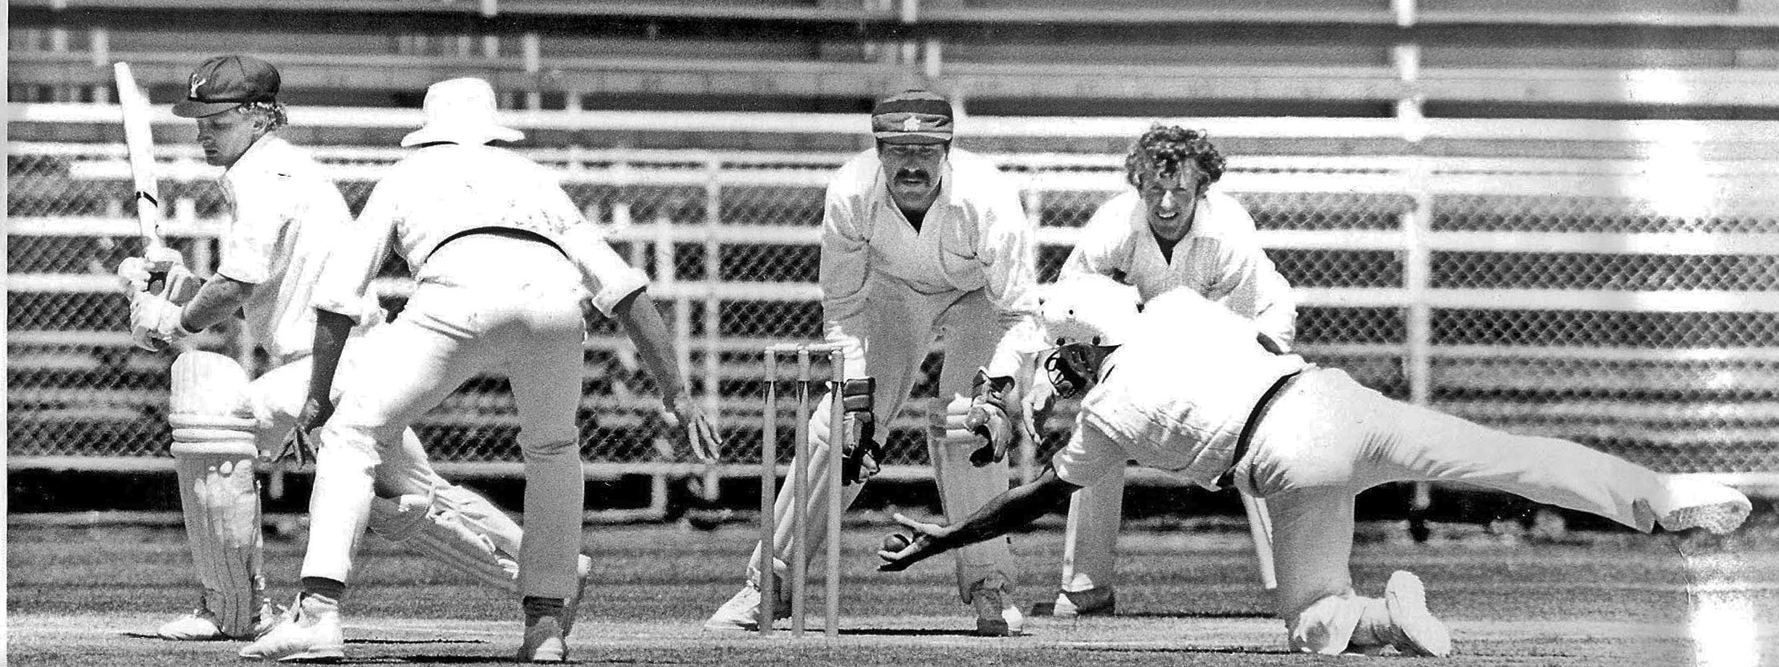

**John Smith caught by Gary MacDonald. Ash Hart wicket keeper, Rod Fulton first slip.**

**Lancaster Park 13 January 1985**

**Canterbury 246 and 280 Central Districts 150 and 254 Canterbury won by 122 runs**